FOR IMMEDIATE RELEASE Contact:
Email: info@sascharaeburn.com
Website: www.scribblethesnail.com

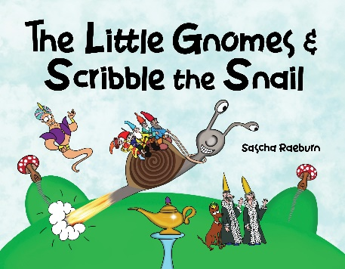
Royal gnomes, magical snails, dragons, and aliens make this illustrated picture book a charmed globe-trotting adventure!

Children’s book themes with magic, kingdoms, dragons, or outer space are always crowd pleasers. Put them all together in one book and you have a picture book that will delight any young reader. With her new picture book release, The Little Gnomes & Scribble the Snail, author and illustrator Sascha Raeburn brings an adventurous story of a magical snail as he travels the world—and the universe! —searching for two royal gnome children who have gone missing.

In the vibrant kingdom of Gnomeland with its comfy mushroom homes, the beloved prince and princess are missing after a magical genie grants their wish to visit faraway places. The three gnome leaders vow to the king and queen that they will find the royal children and return them safely back to the village. A traveling adventure ensues with the leaders meeting an assortment of interesting characters along the way—even an alien in outer space who brings them to Mars to meet with a wise wizard and his magical snail, Scribble.

The rocket-fast snail, using its mega GPS tracker, transports the gnome leaders on a whirlwind world search expedition, soaring past the Great Pyramids of Egypt, over the Eiffel Tower in Paris, past the Sydney Opera House and more. Will Scribble the snail and the gnome leaders rescue the prince and princess before it’s too late?

With a charming text and vibrant and richly detailed illustrations to pore over on each spread, Raeburn’s The Little Gnomes & Scribble the Snail is an imaginative and lively tale for bedtime and together time. Sascha Raeburn is an award-winning actress who has also received worldwide recognition for her writing, producing and directing. Her book is available now wherever books are sold.

###

If you would like more information about author Sascha Raeburn and The Little Gnomes & Scribble the Snail, please email: info@sascharaeburn.com or www.scribblethesnail.com

